WEB SERVICES

1. creating soap project with wsdl, how to send request xml

Open SOAP UI 🡪 Go to New SOAP project 🡪 Enter the name and WSDL 🡪 Click Ok

I have used a currency convertor wsdl <http://www.webservicex.net/CurrencyConvertor.asmx?WSDL>

To run, go to Request 1 🡪 Click on Run

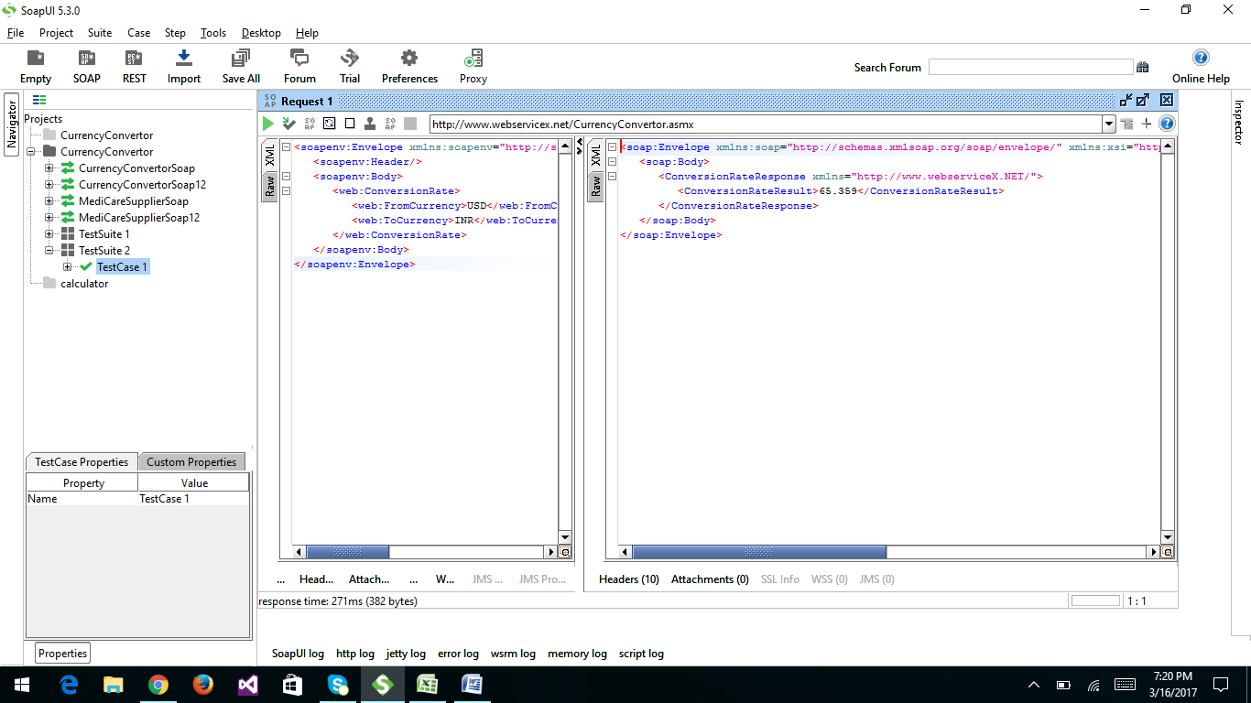

1. Creating test suite, test case, test steps

Creating test suite: Right click on project 🡪 go to new test suite 🡪 Give name, click OK

Creating test case: Right click on Test Suite🡪 go to new test case 🡪 Give name, click OK

Creating test step: Right click on Test case🡪 go to add step🡪 Select SAOP request 🡪Give name, click OK

1. Validating request xml, response xml using xsd

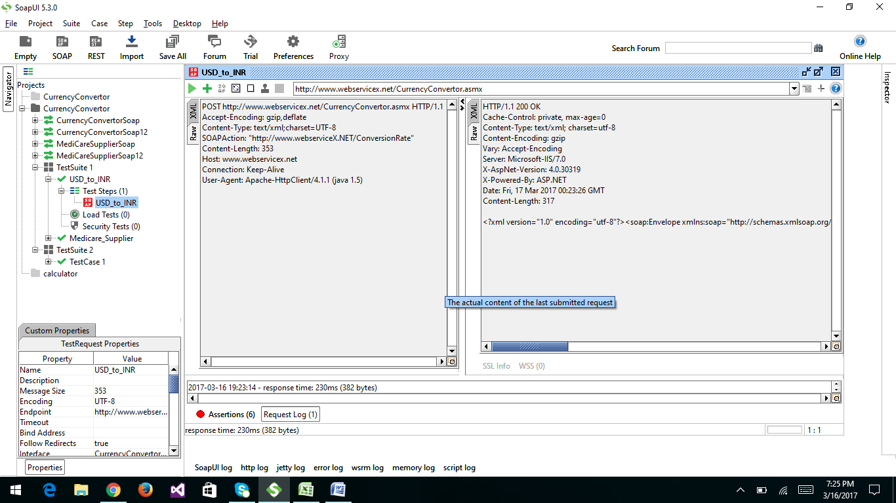

1. Reading data from response xml using assertions

